SMS Light Control Using Arduino and GSM Module

## Project Description

This project is aimed at making automation through SMS. GSM module is connected to Arduino UNO with a SIM card inside the module. When we send one SMS from to this GSM module sim number, SMS is received at module and our arduino sketch (code) read that SMS. Based on SMS text we are sending command turn or off the light.

## Requirements

• SIM900 Module

• Arduino UNO

• Sim Card

• Jumper wires

## Circuit Diagram

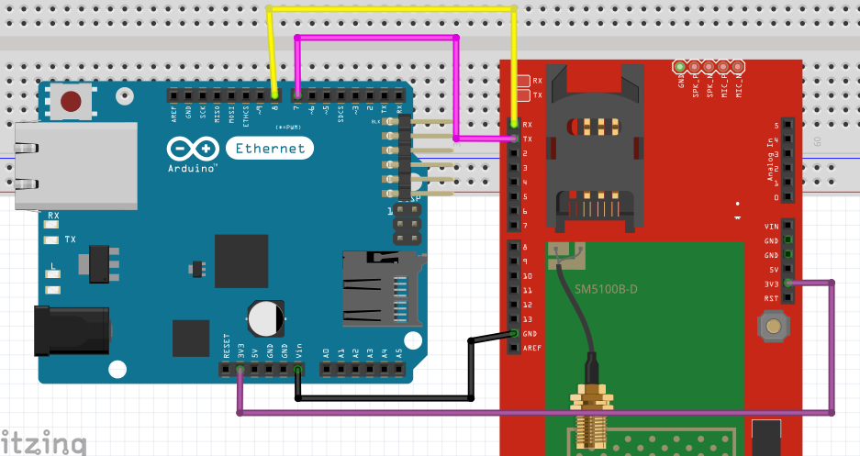

## Source Code

#include <SoftwareSerial.h>

// Configure software serial port

SoftwareSerial SIM900(7, 8);

// Variable to store text message

String textMessage;

// Create a variable to store Lamp state

String lampState = "HIGH";

// Relay connected to pin 3

const int relay = 3;

void setup() {

// Automatically turn on the shield

digitalWrite(9, HIGH);

delay(1000);

digitalWrite(9, LOW);

delay(5000);

// Set relay as OUTPUT

pinMode(relay, OUTPUT);

// By default the relay is off

digitalWrite(relay, HIGH);

// Initializing serial commmunication

Serial.begin(19200);

SIM900.begin(19200);

// Give time to your GSM shield log on to network

delay(20000);

Serial.print("SIM900 is ready to send receive sms");

// AT command to set SIM900 to SMS mode

SIM900.print("AT+CMGF=1\r");

delay(100);

// Set module to send SMS data to serial out upon receipt

SIM900.print("AT+CNMI=2,2,0,0,0\r");

delay(100);

}

void loop(){

if(SIM900.available()>0){

textMessage = SIM900.readString();

Serial.print(textMessage);

delay(10);

}

if(textMessage.indexOf("ON")>=0){

// Turn on relay and save current state

digitalWrite(relay, LOW);

lampState = "on";

Serial.println("Relay set to ON");

textMessage = "";

}

if(textMessage.indexOf("OFF")>=0){

// Turn off relay and save current state

digitalWrite(relay, HIGH);

lampState = "off";

Serial.println("Relay set to OFF");

textMessage = "";

}

if(textMessage.indexOf("STATE")>=0){

String message = "Lamp is " + lampState;

sendSMS(message);

Serial.println("Lamp state resquest");

textMessage = "";

}

}

// Function that sends SMS

void sendSMS(String message){

// AT command to set SIM900 to SMS mode

SIM900.print("AT+CMGF=1\r");

delay(100);

// change to your sim900's your phone number

SIM900.println("AT + CMGS = \"9986120923\"");

delay(100);

// Send the SMS

SIM900.println(message);

delay(100);

// End AT command with a ^Z, ASCII code 26

SIM900.println((char)26);

delay(100);

SIM900.println();

// Give module time to send SMS

delay(5000);

}

## References

<https://myelectronicslab.com>

<https://www.arduino.cc>

<https://www.youtube.com>

## Snapshots

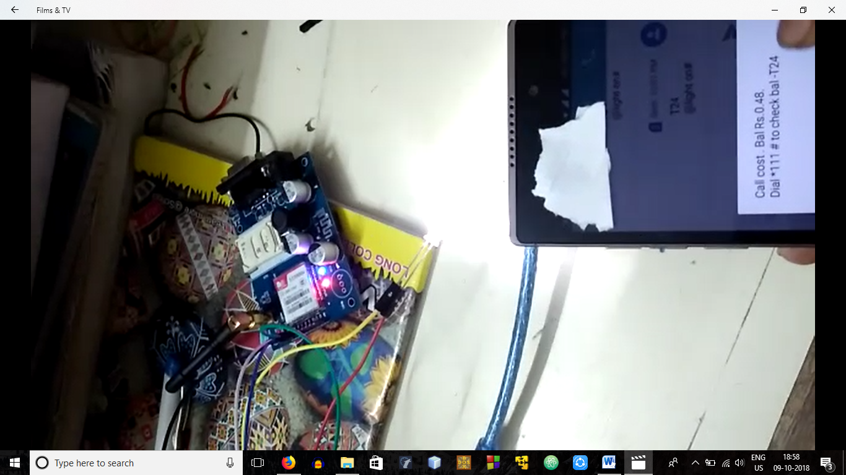

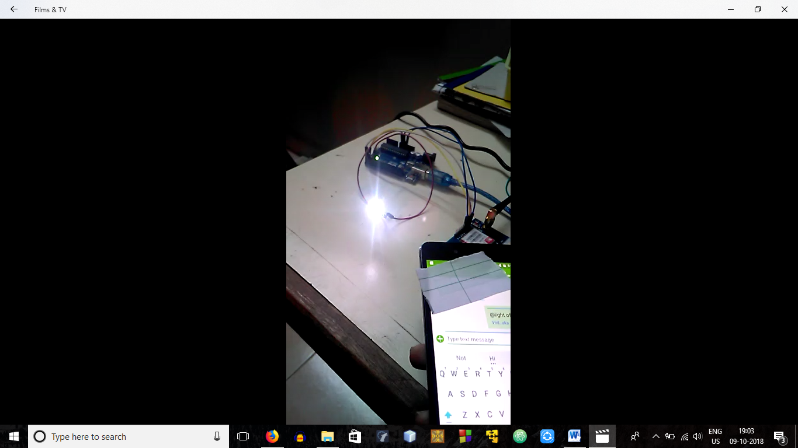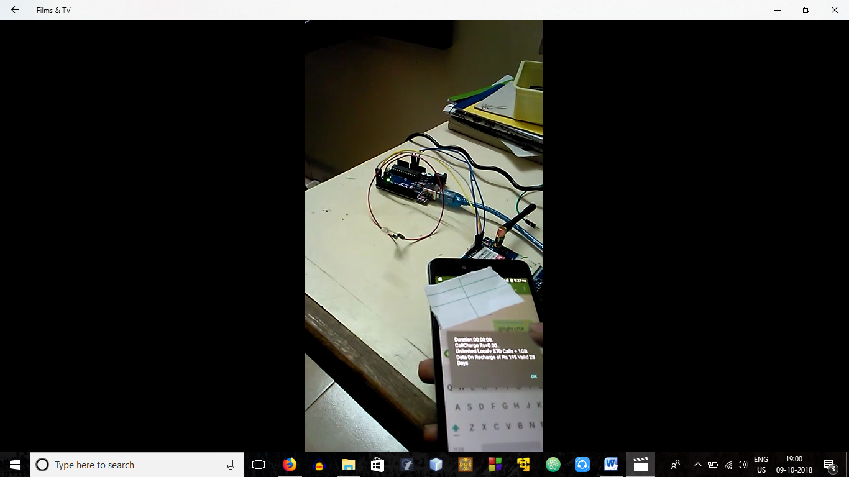

## Videos

<https://drive.google.com/file/d/1mI-K6BL1cbGkKFnMgQaO4pNaeWpJTBZz/view?usp=sharing>

<https://drive.google.com/file/d/1Nhq8KHSCqWw_10WrXsnlM7Yojl3bcAwp/view?usp=sharing>

## Project By

1. Ganesh Manu Mahesh Kashyap
2. N Nithin Srivatsav
3. Pareekshith US Katti
4. Ponnanna M.B